**ARYAMAN MISHRA**

**19BCE1027**

**1)** import java.util.*;

class Addressbook

{

public String name,address,pro;

public int age,salary;

Addressbook()

{

name="";

pro="";

age=0;

salary=0;

}

public Addressbook(int age,int salary,String name,String address,String pro)

{

this.age=age;

this.salary=salary;

this.name=name;

this.address=address;

this.pro=pro;

}

public void Person()

{

System.out.println("Name:"+name);

System.out.println("Age:"+age);

System.out.println("Salary:"+salary);

System.out.println("Address:"+address);

System.out.println("Profession:"+pro);

}

public static void main(String[] args) {

Scanner sc = new Scanner(System.in);

System.out.print("Enter number of People. ");

int n = sc.nextInt();

int i,a,b;

String c,d,e;

Addressbook[] arr=new Addressbook[n];

for(i=0;i<n;i++)

{

System.out.println("Enter Name.");

c=sc.next();

System.out.println("Enter Age.");

a=sc.nextInt();

System.out.println("Enter Salary.");

b=sc.nextInt();

System.out.println("Enter Address.");

d=sc.nextLine();

sc.nextLine();

System.out.println("Enter Profession.");

e=sc.nextLine();

sc.nextLine();

try {

if(a >= 100)

throw new ArithmeticException("Age must be less than 100");

else

System.out.println("Valid age");

}

catch (ArithmeticException ex) {

System.out.println(ex);

System.out.println("Enter Age again but less than 100.");

a=sc.nextInt();

}

arr[i]=new Addressbook(a,b,c,d,e);

}

for(i=0;i<n;i++)

{

arr[i].Person();

}

}

}

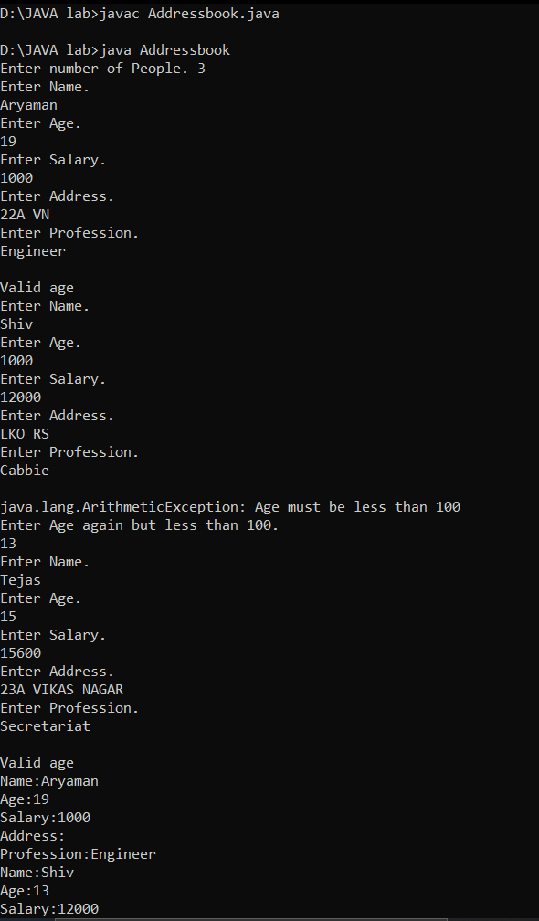

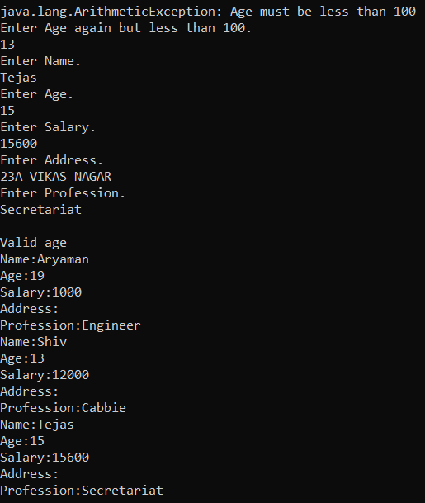

**2)** import java.util.*;

class ThreadA extends Thread{

int x;

ThreadA(int x)

{

this.x=x;

}

public void run( ) {

double y=Math.toRadians(x);

double z=Math.sin(y);

System.out.print("p="+z);

}

}

class ThreadB extends Thread {

int x;

ThreadB(int x)

{

this.x=x;

}

public void run( ) {

double y=Math.toRadians(x);

double z=Math.cos(y);

System.out.print("+"+z);

}

}

class ThreadC extends Thread{

int x;

ThreadC(int x)

{

this.x=x;

}

public void run( ) {

double y=Math.toRadians(x);

double z=Math.tan(y);

System.out.print("+"+z);

}

}

public class Trig {

public static void main(String args[]) {

Scanner sc=new Scanner(System.in);

System.out.println("Enter value for x y and z in p = sin (x) + cos (y) + tan (z).");

int x=sc.nextInt();

int y=sc.nextInt();

int z=sc.nextInt();

ThreadA a = new ThreadA(x);

ThreadB b = new ThreadB(y);

ThreadC c = new ThreadC(z);

a.start();

b.start();

c.start();

}

}

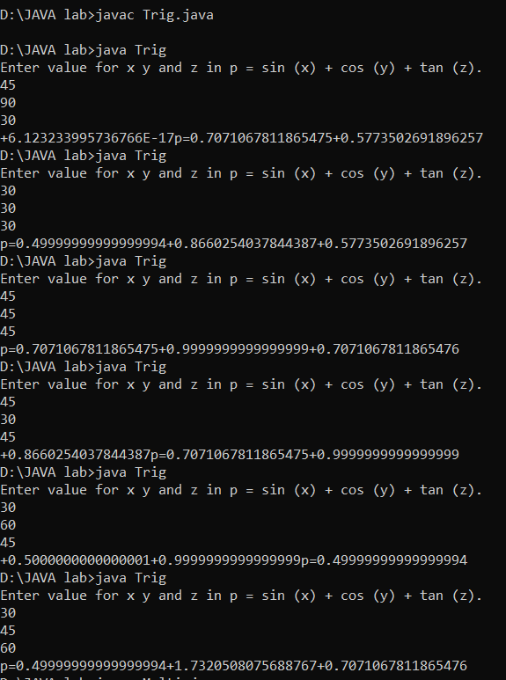

**3)** import java.util.*;

public class Multi{

public static void main (String args[]){

Scanner sc = new Scanner (System.in);

System.out.print("Enter a number : ");

int n = sc.nextInt();

if (n < 1) {

throw new ArithmeticException("Kindly enter a number greater than 0");

}

else {

int i;

for (i=1;i<11;i++){

System.out.println(n + "x" + i + "=" + n*i);

}

}

}

}

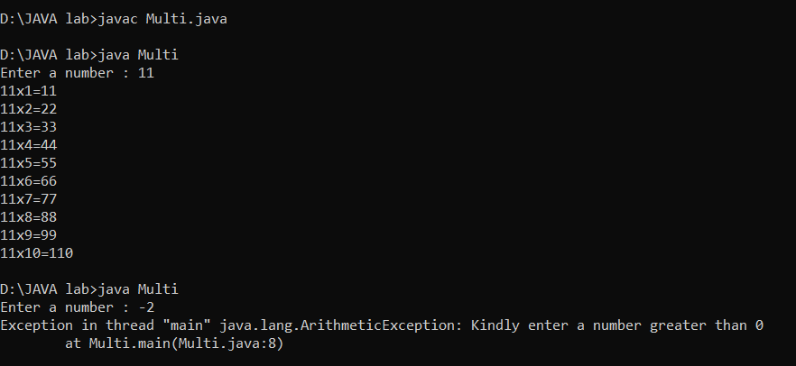

**4)** import java.util.Scanner;

import java.util.InputMismatchException;

public class Average {

public static void main(String args[]) {

double total = 0, N, userInput;

Scanner input = new Scanner(System.in);

while (true) {

System.out.print("Enter how many numbers(N) to calculate average:");

userInput = input.nextDouble();

if (userInput > 0) {

N = userInput;

break;

} else

System.out.println("N must be positive.");

}

for (int i = 0; i < N; i++) {

while (true) {

System.out.print("Enter number:");

try {

userInput = input.nextDouble();

total += userInput;

break;

} catch (InputMismatchException e) {

input.nextLine();

System.out.println("Input must be number");

}

}

}

System.out.println("Average: " + total / N);

}

}

